Sellotape  
Clever Tape

SKU: 907158,1766010,1569070

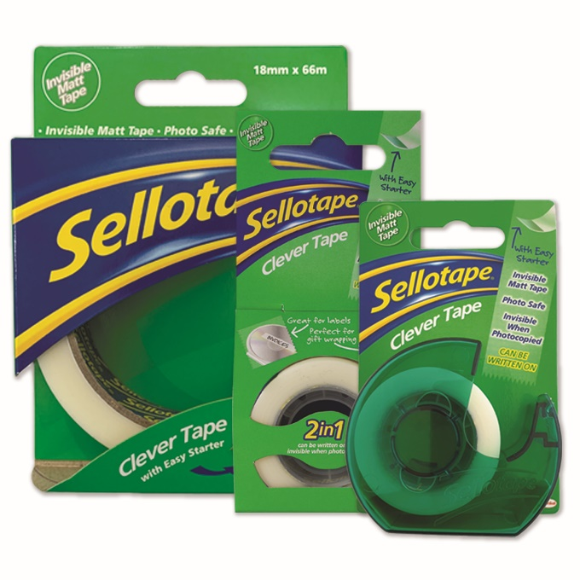

DESCRIPTION

Sellotape Clever Tape is a matt BOPP film coated with an acrylic emulsion adhesive, and is release-coated for easy unwinding. Clever Tape is long aging and does not ooze or discolour.

Sellotape Clever Tape is frosty in appearance on the roll and the tape becomes invisible when applied. Sellotape Clever tape is easy tear, photo safe and invisible when photocopied. Film will accept typewriting, Indian Ink, ball-point pen and pencil.

Final visibility is dependent on surface.

|  |  |
| --- | --- |
| SPECIFICATIONS | |
| Backing | BOPP |
| Adhesive | Acrylic |
| Thickness | 50 microns ± 3 |
| Peel Adhesion | ≥0.40 kg per inch |
| Tensile strength | ≥5.0 kg per inch |
| Elongation | 50% |
| Colour | White |

APPLICATIONS

* Permanent invisible repair to books, documents and drawings of all types
* Joining and repairing of material to be photocopied
* Drafting, office and general use
* Great for labelling